### Part # 1 Setting up NetSuite to Use SDF

<https://videohub.oracle.com/media/Setting+up+NetSuite+to+Use+SDF/1_67268uoj>

### Part # 2 Installing the Eclipse IDE

<https://videohub.oracle.com/media/Installing+the+Eclipse+IDE/1_3ci0ulcd>

### Part # 3 Configuring the Eclipse IDE Plug-in for SDF

https://videohub.oracle.com/media/Configuring+the+Eclipse+IDE+Plug-in+for+SDF/1_1hoqvk5c

### Add the SuiteCloud IDE Plug-in for Eclipse Update Site

When you add the IDE plug-in update site to Eclipse, you can download the latest version of the IDE plug-in that is compatible with your NetSuite account.

#### **To add the SuiteCloud IDE Plug-in update site in Eclipse:**

1. Launch Eclipse. If you are prompted to select a workspace, accept the default. You can change it later. For more information, see [Selecting a Workspace](https://docs.oracle.com/en/cloud/saas/netsuite/ns-online-help/section_N2911854.html).
2. Go to **Window** > **Preferences**. The Preferences window appears.
3. Add the IDE Plug-in update site as follows:
   1. In the navigator, select **Install/Update** > **Available Software Sites**.
   2. Click **Add**. The Add Site window appears.
   3. Enter the following information:

| Option | Description |
| --- | --- |
| Name | SuiteCloud IDE Plug-in for Eclipse Update Site |
| Location | Note:  For compatibility reasons, your IDE plug-in version must match the version of your NetSuite account.  If your account is on version 21.2, use:  https://system.netsuite.com/download/suitecloud-sdk/ideplugin/eclipse/21.2  For accounts on version 21.1, use:  https://system.netsuite.com/download/suitecloud-sdk/ideplugin/eclipse/21.1 |

* 1. Click **OK**.

**SuiteCloud IDE Plug-in for Eclipse Update Site** appears in the list of **Available Software Sites**. Leave all other sites checked.

1. Click **OK**.

### Install SuiteCloud IDE Plug-in for Eclipse

When you install the IDE plug-in, select the update site as your installation source.

#### **To install SuiteCloud IDE plug-in for Eclipse :**

1. Go to **Help** > **Install New Software**. The Install window appears.
2. In the **Work with** dropdown list, select **SuiteCloud IDE Plug-in for Eclipse Update Site**.
3. In the **Name** column, select **SuiteCloud IDE**.
4. Click **Next** to view the installation details.
5. Accept the terms of the license agreement and click **Finish**.

Eclipse installs the IDE plug-in. When the installation is complete, click **Yes** to restart Eclipse.

When Eclipse restarts, the IDE plug-in Setup Wizard opens. For information and instructions, see [Launching SuiteCloud IDE Plug-in for Eclipse and Using the Account Setup Wizard](https://docs.oracle.com/en/cloud/saas/netsuite/ns-online-help/section_N2911568.html).

### Verify the Installation of SuiteCloud IDE Plug-in for Eclipse

When you install the IDE plug-in, information about its version is added to the About Eclipse dialog box. You can verify this installation information at any time.

#### **To verify the installation of SuiteCloud IDE plug-in for Eclipse:**

1. Go to **Help** > **About Eclipse**.
2. Click the NetSuite icon or click **Installation Details** to open the About Eclipse Features window.

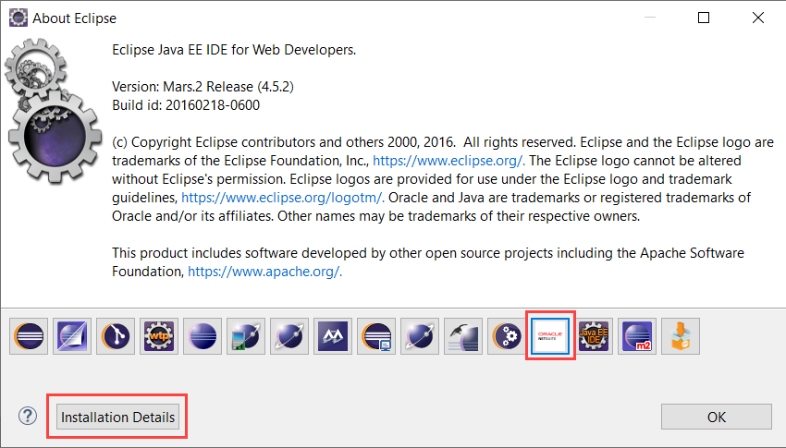

The IDE plug-in version information is displayed.

## **Using Existing SDF Projects with a New Eclipse Installation**

You can use your existing SDF projects with a new IDE plug-in for Eclipse Mars installation.

To use existing SDF projects with a new installation:

1. Back up your existing Eclipse installation and workspace.
2. Download and install Eclipse Mars. See [Downloading Eclipse for Use with SuiteCloud IDE Plug-in](https://docs.oracle.com/en/cloud/saas/netsuite/ns-online-help/bridgehead_4026070076.html).
3. Install the latest version of the Eclipse plug-in. See [Updating Eclipse for Use with SuiteCloud IDE Plug-in](https://docs.oracle.com/en/cloud/saas/netsuite/ns-online-help/bridgehead_4026080311.html). The complete steps for the Eclipse plug-in installation and configuration are available in [Setting Up SuiteCloud IDE Plug-in for Eclipse](https://docs.oracle.com/en/cloud/saas/netsuite/ns-online-help/section_N2905859.html).
4. Configure the IDE plug-in to use your account. See [Launching SuiteCloud IDE Plug-in for Eclipse and Using the Account Setup Wizard](https://docs.oracle.com/en/cloud/saas/netsuite/ns-online-help/section_N2911568.html).
5. If you are using a new workspace for Eclipse Mars, perform the following steps to use your SDF projects with the new workspace:
   1. Copy your existing SDF projects to the new workspace.
   2. To add an existing SDF project to the IDE plug-in, create each project individually using the same name. The IDE plug-in populates the NS Explorer subtab with the existing files for the SDF project that matches the specified name. To create a project, see [Creating an Account Customization Project in SuiteCloud IDE Plug-in for Eclipse](https://docs.oracle.com/en/cloud/saas/netsuite/ns-online-help/section_4724782675.html) and [Creating a SuiteApp Project in SuiteCloud IDE Plug-in for Eclipse](https://docs.oracle.com/en/cloud/saas/netsuite/ns-online-help/section_4847626592.html).

# **Enabling SuiteCloud Development Framework in the Target NetSuite Account (Admin Only)**

To use SuiteCloud Development Framework (SDF) with a target NetSuite account, certain features must be enabled by an account administrator. For information about enabling features, see:

* [Enabling Features](https://docs.oracle.com/en/cloud/saas/netsuite/ns-online-help/chapter_N232138.html)
* [SuiteCloud Features](https://docs.oracle.com/en/cloud/saas/netsuite/ns-online-help/bridgehead_N239332.html)

#### **To set up a NetSuite account for SDF**

1. Log in to NetSuite with an administrator role.
2. Go to **Setup** > **Company** > **Enable Features**.
3. On the **SuiteCloud** tab, enable the following features:
   * Custom Records
   * Web Services (SuiteTalk)
   * SuiteCloud Development Framework
   * To use TBA, enable the Token-Based Authentication feature.
   * To use custom code and server SuiteScript, enable **Client SuiteScript** and **Server SuiteScript**.
   * To use Transaction fields, enable **Item Options**.
   * To use Custom Transactions, enable **Custom Transactions**.
   * To use advanced PDF/HTML templates, enable **Advanced PDF/HTML Templates**.
   * To use SSP Applications, enable **SuiteScript Server Pages**.

Note:

If you use SSP applications, the SuiteCommerce module must be provisioned to the NetSuite account.

* + To use Workflows, enable **SuiteFlow**.
  + To use Custom Segments, enable **Custom Segments**.
  + To use the Workbook API (Beta), including Dataset Builder Plug-ins and Workbook Builder Plug-ins, enable **Workbook API (Beta)**.

On the **Company** tab, to use Translation Collections, enable **Multi-Language**.

1. Depending on the types of records you work with, enable the following features:
   * To use KPI scorecards, on the **Analytics** tab, enable **KPI Scorecards**.
   * To use SuiteAnalytics Workbook or the Workbook API (Beta), on the **Analytics** tab, enable **SuiteAnalytics Workbook**.
   * To use address forms, go to the **Company** tab. On the **Classifications** Subtab, enable **Locations**.
   * To use SSP Applications, on the **Web Presence** tab, enable **Web Site** and **Host HTML Files**.
   * To use CMS Content Types, on the **Web Presence** tab, enable **Site Management Tools.**

Note:

Site management tools are only available in SuiteCommerce Advanced accounts. For more information, see [Upgrade SuiteCommerce to SuiteCommerce Advanced](https://docs.oracle.com/en/cloud/saas/netsuite/ns-online-help/chapter_1522935586.html).

Next, you should create and assign a customized Developer role to use with the account for SDF development. For more information, see [Assigning the Developer Role (Admin Only)](https://docs.oracle.com/en/cloud/saas/netsuite/ns-online-help/section_4724921075.html).

**Others Settings**

1. Configure the SuiteCloud IDE plugin
   1. When Eclipse restarts, you will be prompted to set up the SuiteCloud plugin with a master password and default NetSuite account
   2. After completing this set up wizard, navigate to *Preferences* > *NetSuite*
      * Here you will find all of the SuiteCloud IDE preferences
   3. [Optional] If your primary use for Eclipse is NetSuite development, navigate to *Preferences* > *General* > *Perspectives* and make the "NetSuite" Perspective your default
2. Create a new NetSuite project
   1. Right-click in the *NS Explorer* window and select *New* > *NetSuite project*
   2. Follow the wizard for the project setup of your choosing. The project types are as follows:
      * *Account Customization*: A project that leverages the *SuiteCloud Development Framework* for building custom objects, records, and scripts for customizing a NetSuite account.
      * *SuiteScript*: A project used exclusively for writing scripts.
      * *SSP Application*: A SuiteScript Server Pages application, used typically in conjunction with SiteBuilder or SuiteCommerce for NetSuite-backed E-Commerce applications.